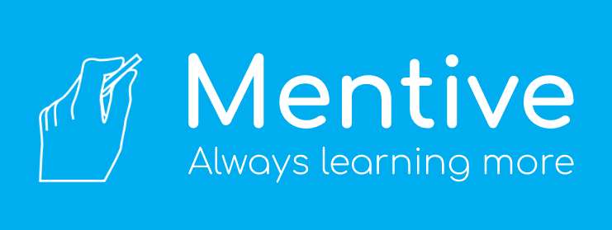

After seeing many students in college not taking advantage of the tutoring resources that they are given, the idea of a peer-to-peer knowledge network online was sparked. The Mentive logo depicts a hand holding chalk, which represents what a teacher does inside of a classroom. This simple act and gesture has allowed billions of people throughout history to achieve the knowledge that creates innovations. Learning is the most important aspect of growth in society, therefore, we should always be learning more.